1ère Conférence Ouest Africaine - Energies renouvelable : coa_er 2020

Titre de votre presentation

M. Sène^{1,}, D. Diop ², and N. Napo³
¹Leiter, UFR-SAT, Université Gaston Berger
Saint-Louis, SENEGAL
²Ecole Polytechnique de Thiès (EPT),
Thiès, SENEGAL
³Laboratoire d’Energies Renouvelables
Lomé, TOGO

1) Contexte / Motivation

2) Description of approach and techniques

3) Results / Conclusions / Perspectives

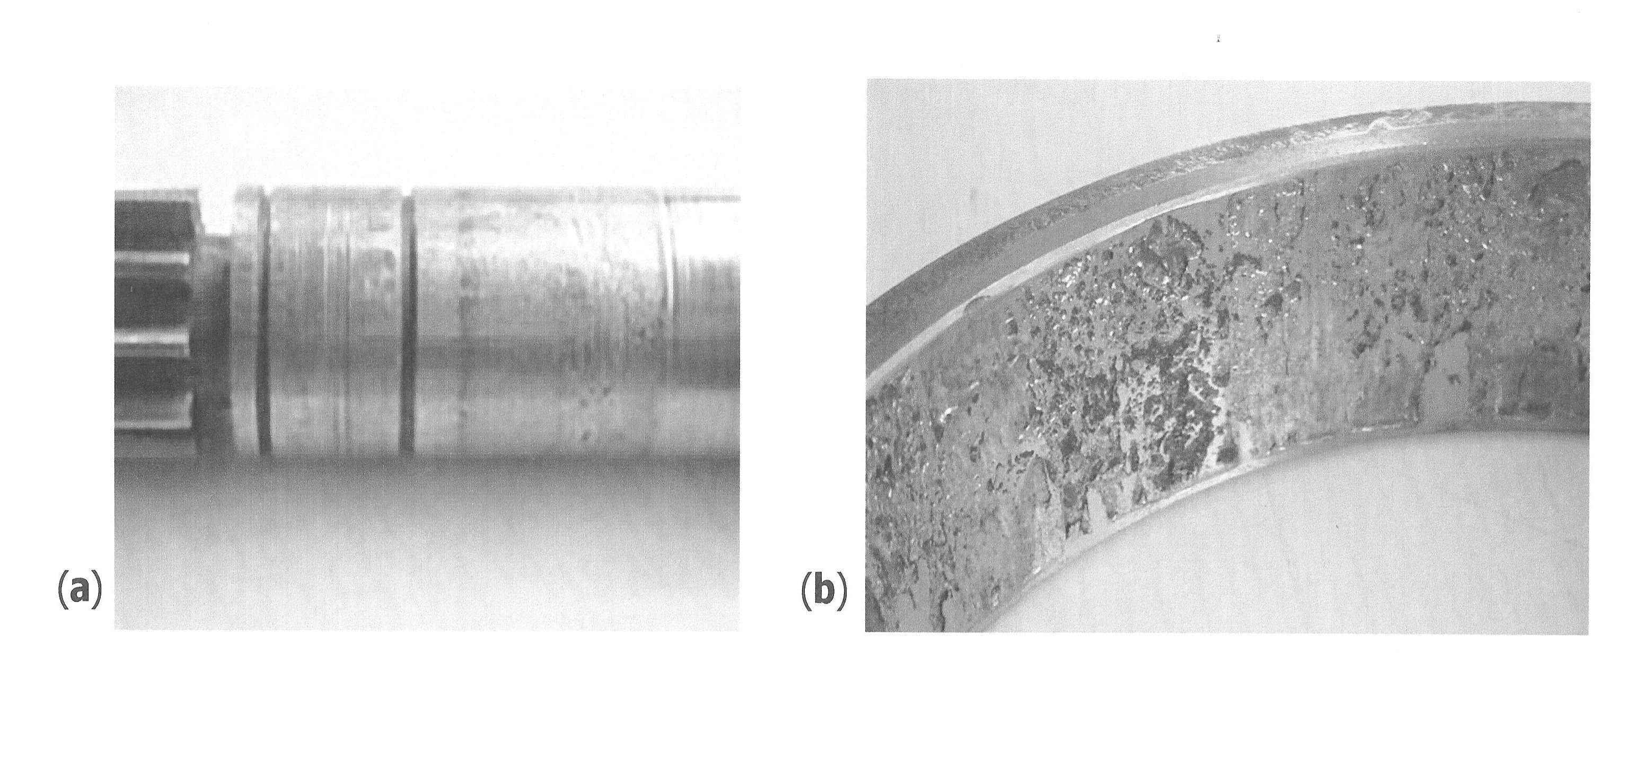

Figure 1: Example of UFD’s effect on turning plant’s rotation axis (a) and FPD (b) in a SKF-6002 bearing device

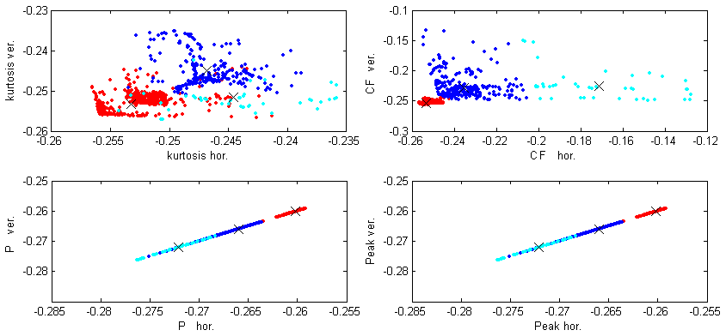
Figure 2. View of …..

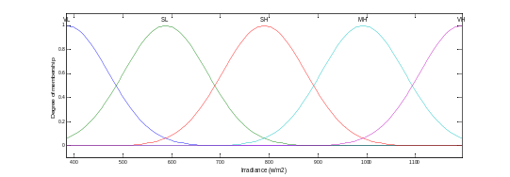
Figure 3. View of beam structure in xxxxxxxxx

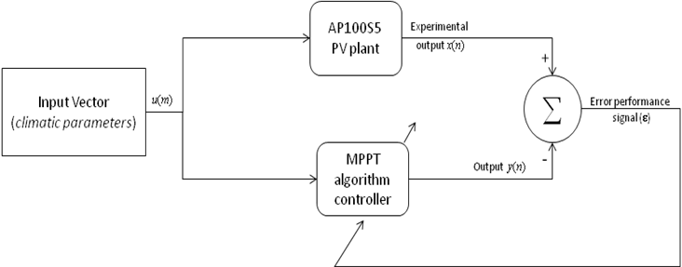
Figure 4. PV module adaptive controller chain

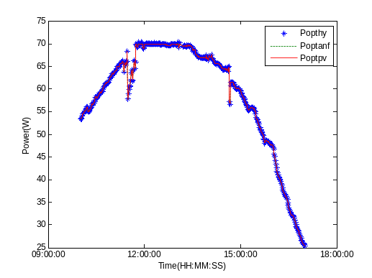
Figure 5. Maximum power issued adaptive neuro-fuzzy controller for a sunny day

Table 1. Sample of a Table Format
Table Head | Table Column Head
Table Head | Table Column Subhead | Subhead | Subhead
Copy | More table copy

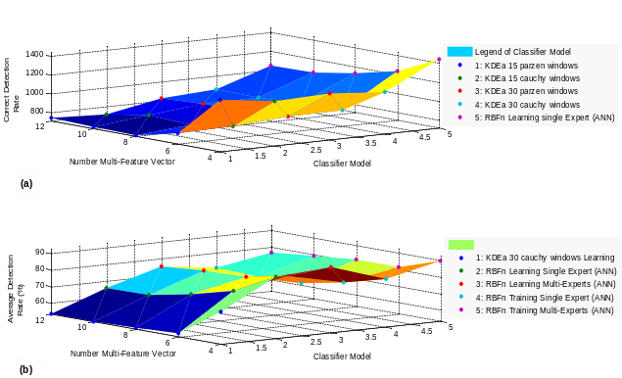

Figure 6. Performances of KDEa and RBFn involving training process for the numbers Multi-Features Vector

REFERENCES:

[1] S. Senturia, “Perspectives on MEMS Past and Future: the Tortuous Pathway from Bright Ideas to Real Products”, in Digest Tech. Papers Transducers‘03 Conference, Boston, June 8-12, 2003, pp. 10-15.
[2] T. Tsuchiya, O. Tabata, J. Sakata, Y. Taga, “Specimen Size Effect on Tensile Strength of Surface Micromachined Polycrystalline Silicon Thin Films”, J. Microelectromech. Syst., vol. 7, pp. 106-113, 1998.
[3] M. Crichton, Prey, Harper Collins Publishers, Inc., New York, 2002.

